MATTHEW MERCER
Table of Contents
MATTHEW MERCER 1
Biography 1
Filmography 2
Critical Role 2

Matthew Christopher Miller, known professionally as Matthew Mercer or Matt Mercer, is an American voice actor involved in English dubs of Japanese anime as well as cartoons, films and video games. In anime shows, he voiced Levi in Attack on Titan, and Trafalgar Law in the Funimation dub of One Piece. In video games, he voices Leon S. Kennedy in the Resident Evil series, McCree in Overwatch, MacCready in Fallout 4 and Rexxar in Hearthstone. In addition to voice-over, Mercer has developed the Dungeons & Dragons gaming sessions called Critical Role, broadcast by Geek & Sundry.

Biography
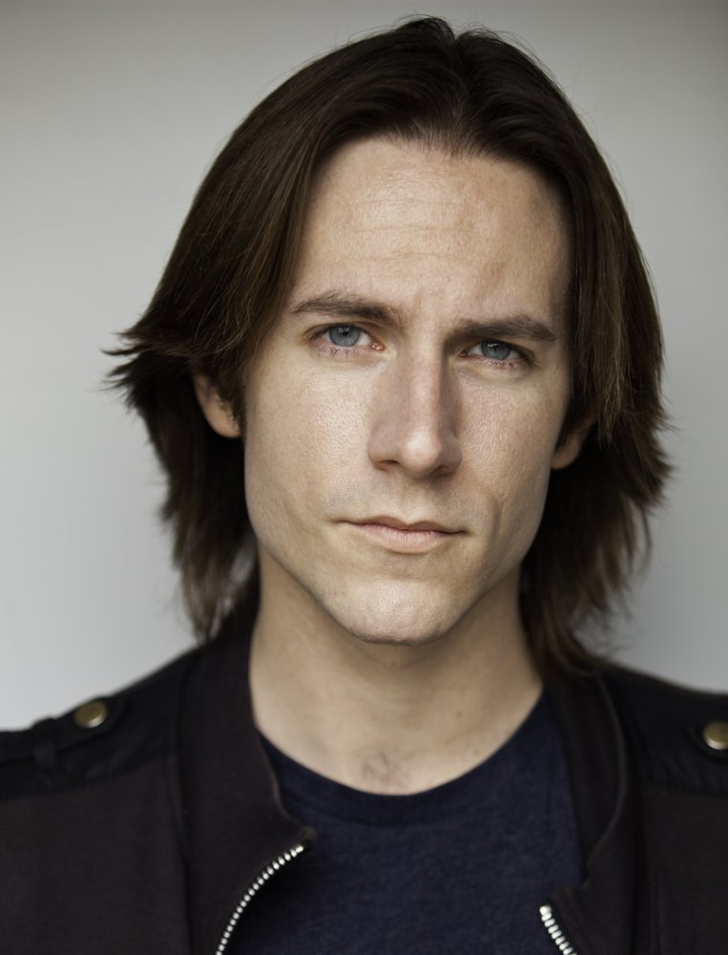
Photo 1: Matthew Mercer
Mercer began his career in high school doing English Walla and additional characters in several Japanese anime, and has since worked with a variety of media, including video games, cartoons, and radio commercials. He has been a guest at conventions around the world, hosting at events such as Anime Expo and Anime Matsuri.
His work has expanded to a multitude of roles in video games, cartoons, and radio commercials. He directed and produced the web series There Will Be Brawl, based on the Super Smash Bros. video game series, where he provided the voices for Kirby and Meta Knight and portrayed the role of Ganondorf. Mercer also acts as the dungeon master in the Geek & Sundry web series Critical Role, leading several other voice actors through a D&D campaign.

Filmography
Matthew Mercer has been the voice of many well-known characters in a variety of animations, films, and video games. The following table lists some of his most notable work as a voice actor:
Genre | Year | Title | Role
Anime | 2014 | Attack on Titan | Levi
Anime | 2015 | One Piece | Trafalgar Law
Anime | 2007–2017 | Naruto: Shippūden | Yamato
Animation | 2015 | DC Super Friends | Superman, Two-Face
Animation | 2017 | Marvel’s Spider-Man | Rhino, Comic Book Guy #1, Reporter
Film | 2013 | Iron Man: Rise of Technovore | Tony Stark
Film | 2017 | Resident Evil: Vendetta | Leon S. Kennedy
Video  Game | 2004 | World of Warcraft | General Vezax, Halion, Captain Drok
Video  Game | 2009 | Street Fighter IV | Fei Long
Video  Game | 2014 | Hearthstone | Rexxar, Nefarian, Ragnaros, others
Video  Game | 2015 | League of Legends | Gangplank, Kindred (Wolf)
Video  Game | 2016 | Overwatch | Jesse McCree

Critical Role
Critical Role is a weekly web series of voice actors playing Dungeon & Dragons, chronicling the adventures of a group known as Vox Machina. The series airs live on the Geek & Sundry Twitch channel on Thursdays at 7pm (Los Angeles time), and episodes are archived on their website.
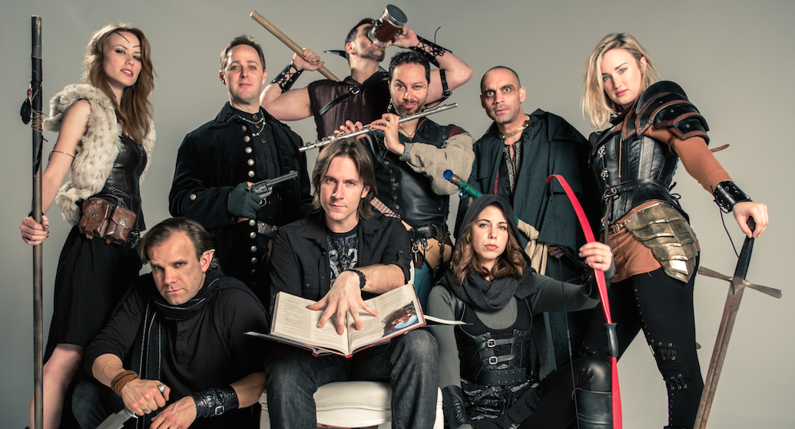
Photo 2: The Critical Role cast, with Matthew Mercer at the center.
Matthew Mercer, who leads Critical Role as the dungeon master, lists role-playing games among the greatest inspirations in his life. He once said the following in an interview:
“A lot of the ground work for me as a performer really began at my at-home role-playing games.”
The series began on March 13, 2015 with the episode "Arrival at Kraghammer", but the group began playing together much earlier in 2012. The series won great acclaim in its first month with its first three episodes, entitled as follows:
- Arrival at Kraghammer
- Into the Greyspine Mines
- Strange Bedfellows
Nine voice actors make up the crew for Critical Role:
- Matthew Mercer, as the dungeon master
- Orion Acaba, playing Tiberius Stormwind
(Orion left Critical Role on October 28th, 2015, due to mutual parting of the ways.)
- Laura Bailey, playing Vex’Ahlia
- Liam O’Brien, playing Vax’Ildan
- Taliesin Jaffe, playing Percival Fredrickstein von Musel Klossowski de Rolo III
- Ashley Johnson, playing Pike Trickfoot
- Marisha Ray, playing Keyleth
- Sam Riegel, playing Scanlan Shorthalt
- Travis Willingham, playing Grog Strongjaw

Content retrieved from https://en.0wikipedia.org/wiki/Matthew_Mercer and http://criticalrole.wikia.com (abridged)
You can watch the episodes on: http://geekandsundry.com/shows/critical-role

